N:\DMS Logo\DMS Logo 2009\DMS-Logo_24bit.png

|  |
| --- |
| Digital Mapping Solutions |
| IntraMaps Roam |
| User Guide |

|  |
| --- |
| Nathan Woodrow  7-23-2013 |

Contents

[Intro 2](#_Toc362339753)

[Interface Overview 2](#_Toc362339754)

[Project Selection 3](#_Toc362339755)

[Loading a project 3](#_Toc362339756)

[Map View 4](#_Toc362339757)

[Navigating the map 4](#_Toc362339758)

[Enable/Disable Aerial Photos 4](#_Toc362339759)

[Editing attribute values 4](#_Toc362339760)

[Moving Features 6](#_Toc362339761)

[Syncing Data Changes 6](#_Toc362339762)

[Enable/Disable GPS 7](#_Toc362339763)

[To Enable 7](#_Toc362339764)

[To Disable 7](#_Toc362339765)

# Help and Support

IntraMaps Roam is fully supported by Digital Mapping Solutions.

This collection of documents outline the installation, configuration, and user guides for the application.

Further support and technical queries can be sent to Digital Mapping Solutions for assistance. Please email [support@mapsolutions.com.au](mailto:support%40mapsolutions.com.au).

# Intro

This user guide will give a workflow overview for using the IntraMaps Roam application. It provides an overview of all the tools and basic usage of IntraMaps Roam.

# Interface Overview

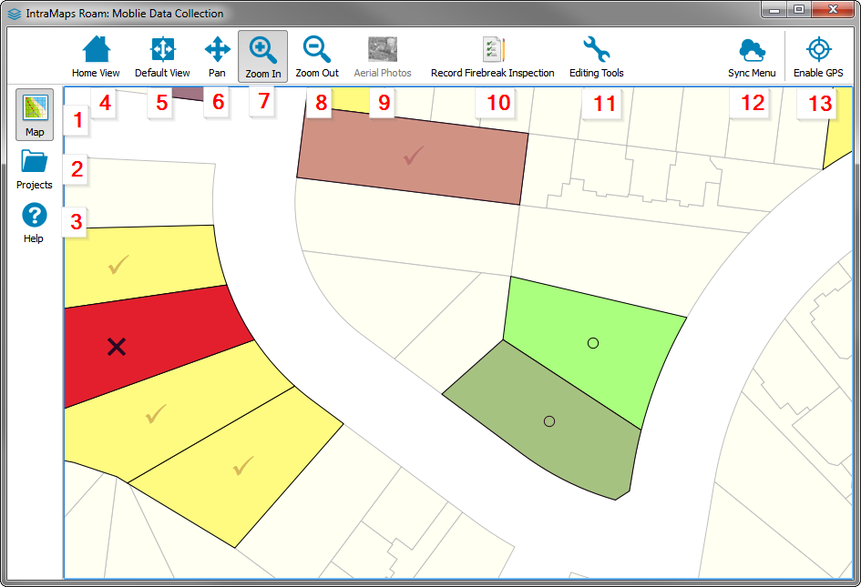

Each item in the UI is as follows:

1. Map View
2. Project Selection
3. Help panel
4. Home View (Full extents)
5. Default View (Project start view)
6. Pan
7. Zoom In
8. Zoom Out
9. Aerial Photos
10. Data entry tool
11. Edit Tools menu
12. Sync Menu
13. Enable GPS

The functions of each of these tools will be covered in the sections below.

# Project Selection

When first launched, IntraMaps Roam will present a project selection screen in order to select the project to load. IntraMaps Roam can contain more than a single project and if installed they will be listed here.

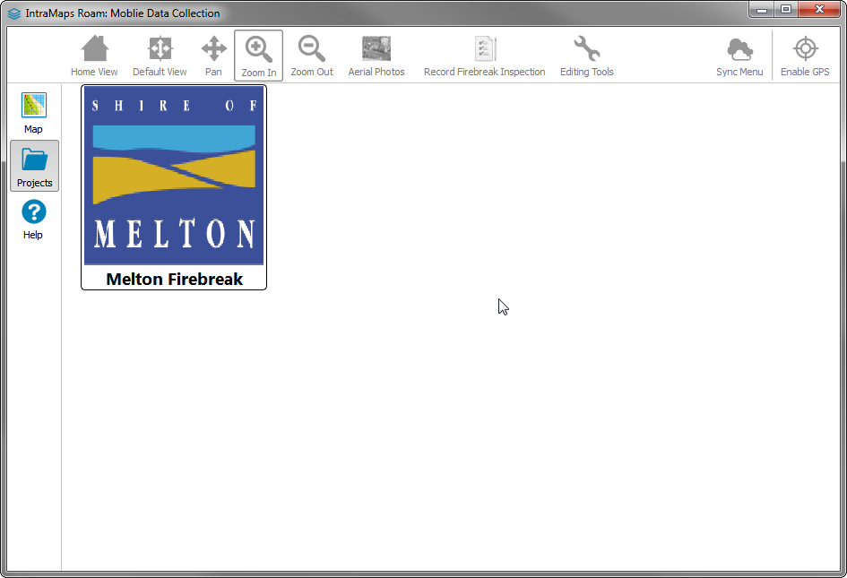

# Loading a project

*Note: Depending on which layers the project contains it can sometimes take a second or so to load.*

1. Select *Projects* btnProjects on the side panel.
2. Single click on the tile for the project.
3. The project will be loaded into the map view

# Map View

After an IntraMaps Roam project is loaded it will be opened in the map view. You can switch projects at any time by following [Project Selection](#_Project_Selection)

# Navigating the map

IntraMaps Roam provides the standard tools to allow for map navigation. IntraMaps Roam also provides touch panning and Pinch-To-Zoom while the Pan tool is selected.

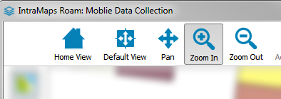

* **Home View** - Zoom the map view to the full extents of the map
* **Default View** - Reset the view that the project loaded with
* **Pan** - Pan the map by dragging.
* **Zoom In** - Click to zoom in, *or* Drag a rectangle to zoom to that extent.
* **Zoom Out** - Click to zoom out

# Enable/Disable Aerial Photos

If the project contains aerial photos that can be enabled or disabled by clicking the Aerial Photos btnAerialPhotos button.

# Editing attribute values

Editing attributes is only supported on configured layers when editing is enabled. These layers are configured by the IntraMaps Roam admin.

1. Select the Edit Tools btnEditTools menu.
2. A pop out menu will be presented
3. Edit Attributes btnEditAttributes will be selected by default
4. Hover over the feature on the map for editing. The feature will be highlighted in orange.

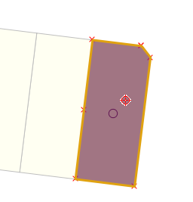

1. Single click the feature.
2. The edit form will open

If more then one feature is under the click point you will be presented with a feature selection screen.

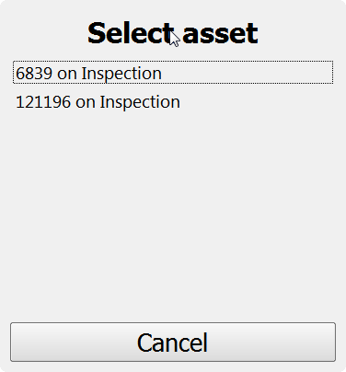

# Moving Features

Moving features is only supported on configured layers. These layers are configured by the IntraMaps Roam admin.

1. Select the Edit Tools btnEditTools menu.
2. A pop out menu will be presented
3. Select Move Feature btnMoveFeature.
4. Click and drag the feature on the map
5. Release to finished the move.

# Syncing Data Changes

Each project can be configured with its own syncing options. The syncing menu will different based on the current project that is loading.

If the project has more than one sync option these will be presented in the Sync Menu as menu options.

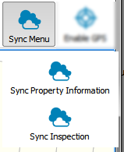

If the project only has a single option the Sync button will revert to a single button that will start the sync process.

A sync progress report can also be viewed by clicking the Status button

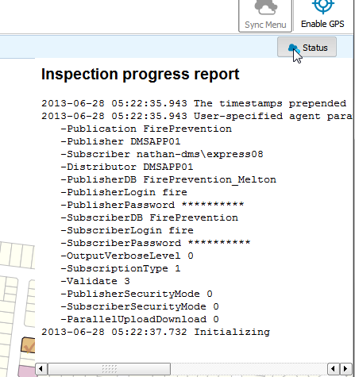

# Enable/Disable GPS

## **To Enable**

1. Select the *Enable GPS* btnGPSEnable button.
2. The GPS will be enabled and a marker shown on the map

Note: The map view will keep the GPS in view at all times. The map will automatically pan when the GPS moves out of view. If you would like to stop this just disable the GPS.

## To Disable

1. Select the *Disable GPS* button.